 | Assignment No. 01  SEMESTER Fall 2024  CS301P- Data Structures (Practical) |  | Total Marks: 20  Due Date: 09-Nov, 2024
Instructions
Please read the following instructions carefully before solving & submitting assignment:
It should be clear that your assignment will not get any credit (zero marks) if:
- The assignment is submitted after the due date.
- The submitted code does NOT compile.
- The submitted assignment is other than .CPP file.
- The submitted assignment does NOT open or file is corrupted.
- The assignment is copied (from other student or ditto copy from handouts or internet).
Uploading instructions
For clarity and simplicity, you are required to Upload/Submit only ONE .cpp template file after completing its code.

Note:
- Use ONLY Dev-C++ IDE.
- Only add the code were commented (// Write your code here) in given .cpp template file. Don’t change any other code otherwise you will lose your marks.
- Only implement these functions addPart(), deletePart(), updateQuantity(), findPart().
Objective
The objective of this assignment is

- To make you familiar of Programming with Linked List Data Structure.
- Develop and implement essential operations on linked lists using class-based objects to manage an inventory of computer parts effectively.
- Enhance your skills in object-oriented programming and gain practical experience with dynamic data structures.

For any query about the assignment, contact at cs301p@vu.edu.pk

GOOD LUCK

 |  | Marks: 20

You are tasked with developing the "Computer Parts Management System," designed to manage the inventory of a computer parts store using Linked List data structure. The system should store details about each computer part, including its ID, name, and quantity in stock. It must support adding new parts, removing parts, updating the quantity of parts, and finding parts in the inventory.

Tasks:
- Understand the provided code:
Read and understand the given .cpp file which is uploaded on VULMS with your assignment file. This file outlining the class structure for managing the computer parts inventory.
- Implement the addPart() function:
Complete the method to add a new part to the inventory linked list.
- Implement the deletePart() function:
Complete the method to remove a part from the inventory based on the part ID.
- Implement the updateQuantity() function:
Complete the method to update the stock quantity for an existing part.
- Implement the findPart() function:
Complete the method to find and display a part by its part ID.
- Mention your own student id instead of BCxxxxxxxxx as given in the output screenshot.

Note:
- Especially handle head, current and previous pointers properly in all four functions using liked list.
- After completing your code your output will be like the given output screenshot.

Sample Output Screenshot:
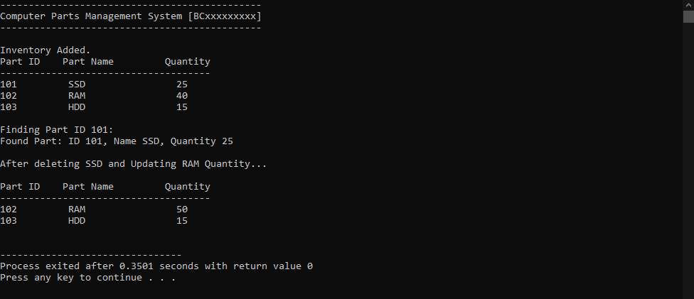

Lectures Covered: This assignment covers Lab # 1. (First three lectures of CS301).
Deadline: Your assignment must be uploaded/submitted on or before, Nov 09, 2024.

